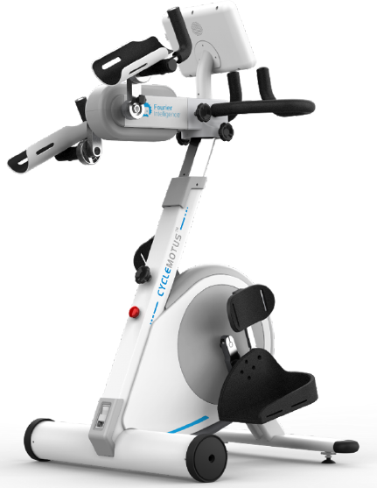
Description :-
- Lower Extremity Training Sitting Posture
- Upper Extremity Training Sitting Posture
- Interval Training for Upper and Lower Extremity
- Synchronous Training for Upper and Lower Extremity Sitting Posture
- Adjustable Training Parameters
- Immersive Interactive Games
- Digitisation of the Whole Training Process
- Symmetry Training

