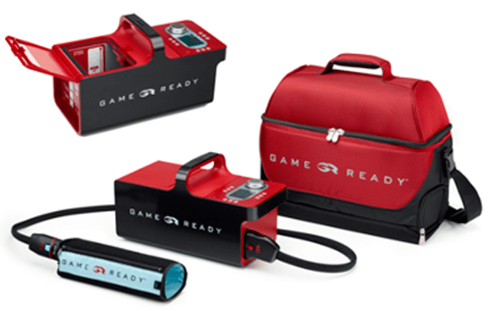
Game Ready® offers innovative, multi-modality recovery systems that help people finish strong and get back to what matters after injury or surgery. Thousands of patients, elite athletes, professional teams in every sport, special military forces, leading orthopedic surgeons, sports medicine doctors, physical therapists, and athletic trainers around the world have chosen Game Ready for over 15 years.
Don’t Just Treat Symptoms, Help Accelerate Recovery
Beyond passive cold and compression applications, Game Ready is the proactive power to help heal.
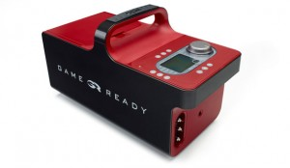Game ready ice machine is an innovative ACCEL™ Technology (Active Compression and Cold Exchange Loop) that combines active compression and cold therapy in a revolutionary treatment system. Now you have the therapeutic power to enhance lymphatic function, encourage blood flow, and help stimulate tissue repair. For acute musculoskeletal injury and post-op recovery, go with the new standard of care.
We rent out the Game Ready for home use following surgical procedures. Please call our office to rent it today!

Cold Therapy in Columbia, MD and Surrounding Areas
What is Cold Therapy?
Cold therapy is a form of Cryotherapy. The practice of cold therapy compression reduces blood flow to a particular area, generally the area that is healing from an injury or surgery. The reduction of blood flow decreases inflammation and swelling that would otherwise cause pain and discomfort, specifically around joints and tendons. Cold therapy can also alleviate pain by reducing nerve activity.
If you have ever used ice on an injury, that is a similar form of cold therapy. Game Ready’s cold therapy is a more advanced version of an ice pack on your wrist or sprained ankle that leads to a faster, pain-free recovery.

Some of the Main Benefits of Cold Therapy Include:
- Decreased reliance on Opioids
- Reduced risk of infection
- Reduced pain and Swelling Especially around joints and tendons
- Increase in mobility range of motion
- Improved pain relief
- A more comfortable recovery process

Cold Therapy Compression
What is Cold Therapy Compression?
Cold therapy compression via the rentable game ready machine is recommended for a variety of injuries and surgeries to assist with recovery.
A Game Ready Ice Machine may be recommended to apply cold therapy for elite athletes, collegiate athletes, athletic trainers, and more. Any surgery that has affected your mobility can see an increased level of recovery with cold therapy, as well as severe or acute injuries that also affect the tendons and joints.
Game Ready Ice Machines have been recommended for recovery during the following surgeries or injuries, but you should always contact Elite Chiropractic and Sport to consult with one of our doctors to ensure the enhanced cold therapy is right for you and your body.
- ACL Surgery Recovery
- Muscle Strains or Pulls
- Rotator Cuff Injuries
- Hip Flexor Injuries
- Sprained Ankles or Ankle Surgery
- Spinal Fracture Recovery
- Wrist Surgery
- And many others, just ask!

How Does the Game Ready Ice Machine Work?
The Game Ready Ice Machine takes the basic idea of an ice pack on your injury and elevates it using advanced technology and high-quality compression wraps.
Based on where your injury or surgery occurred, there are several different Game Ready® ATX® Wraps (Active Temperature Exchange) quality fitted for specific areas of the body. All of these Game Ready body wraps are created with an easy-fit in mind, along with proper comfort and anatomic fittings.
A Few of the Many Cold Therapy Game Ready Wraps Include:
- Ankle
- Back
- Vest
- Spine
- Elbow – Straight or Flexed
- Full or Half Leg
- Hand and Wrist
- Knee – Bent or Straight
- Shoulder
- Hip and Groin
The portable game ready machine is simple to prep and operate. In order to use the Game Ready Ice Machine, lift the lid and fill with the recommended amount of ice to create ice water. Based on the recommendations from your doctor, set the intuitive and easy to operate controls to your preferred settings. With the appropriate body wrap on, sit back, and let the Game Ready machine handle the rest.
Some of the settings you can adjust as part of the Game Ready Ice Machine include pressure, temperature, compression, and treatment time. The setting even includes sleep time, so it will automatically restart at the designated intervals, so you don’t have to continually remove and apply the compression body wrap.

Why Do We recommend Cold Therapy Compression?
A healthy athlete’s body is more than capable of recovery from surgery in an average amount of time with minimal complications if everything went smoothly. However, cold compression and cold therapy can greatly ease the process of recovery and improve the recovery process.
The team at Elite Chiropractic and Sport recommends the Game Ready Ice Machine to ease the transition from post-op to full recovery and provide more comfort during the process. A more comfortable healing process has the possibility of reducing stress, and the compress wraps encourage proper healing practices.
Cold therapy via the Game Ready Ice Machine has also been found to reduce the need for Opioids during recovery. Opioids are highly addictive and can be risky to be on for a long period of time. Cold therapy helps reduce pain around the injured location, thus reducing the need for prescription medication and can even cut short the amount of time the Opioids were prescribed for.
As sports medicine is our primary focus and we have every interest in seeing athletes back on their feet, healthy, and training like normal, talk to us about renting the Game Ready Machine. The simple to use design and comfort wraps can really improve the recovery experience and help athletes get back to what they love doing most — training hard and working towards goals. Plus, cold therapy provides an increase in mobility, which can greatly help reduce feelings of stiffness and discomfort.
There’s no reason not to talk to us today about the benefits a Game Ready machine can provide to you in your time of need.

